ECE 111 FINAL PROJECT REPORT

CHIN-CHOU WU

9/17/2023

**SHA-256 and bitcoin hashing**

SHA, which stands for "secure hash algorithm," is a powerful cryptographic technique used to convert data of any size into a fixed-length string of characters in an irreversible manner. There are several variants of SHA, including SHA-1, SHA-256 (part of SHA-2), and SHA-3, each producing hash values of different lengths, such as 160-bit, 256-bit, or 512-bit outputs. Unlike encryption, SHA focuses on data integrity rather than confidentiality, making it invaluable in various industries.

To ensure the security of the algorithm, SHA incorporates six key properties: Compression, Avalanche effect, Determinism, Pre-image resistance, collision resistance, and efficiency.

Compression mandates that the output hash remains a constant length, regardless of the input message's size. This ensures that the hash is always a predictable length, making it easier to work with in applications. Furthermore, Avalanche Effect indicates a tiny change in the input data should result in a significantly different output hash value. This property is crucial because it makes it extremely difficult for an attacker to predict how a change in the input will affect the hash. Moreover, Determinism requires that the same input data always produces the same output hash, regardless of the system or environment in which the algorithm is applied. It ensures consistency and reliability. What’s more, Pre-image resistance means that SHA should be a one-way function, meaning it should be computationally infeasible to reverse the process and obtain the original input from the hash value. Also, Collision resistance indicates that a secure hashing algorithm should be highly unlikely to produce the same hash value for different inputs. Lastly, Efficiency represents that SHA should generate hash values efficiently, without requiring excessive computing power or time. Efficiency is crucial for practical applications, especially when hashing large datasets.

In summary, these properties collectively make it extremely difficult for malicious actors to manipulate or tamper with hashed data, making SHA a cornerstone of modern data security practices.

Our main character today, is a member in this family, SHA-256. It has a broad spectrum of applications spanning various industries. Because of its properties, its applications benefit all those industries and shines light on the power of hashing algorithms.

Its adoption is driven by its numerous benefits, primarily focused on ensuring data integrity, enhancing security, and optimizing efficiency.

One of the prominent applications of SHA-256 is in data integrity verification. It is used to confirm the integrity of data during transmission or storage. By comparing the SHA-256 hash value of received data to the original SHA-256 hash value, any alterations or tampering with the data can be readily detected. This application is widely employed in file transfer protocols such as FTP and HTTP, as well as in backup systems to maintain data consistency over time.

Likewise, SHA-256 is fundamental in digital signatures, ensuring the authenticity and integrity of digital documents or messages. It plays a pivotal role in secure communication protocols like TLS/SSL, where digital signatures employing SHA-256 are employed to validate digital certificates and verify the identity of communication participants.

Just like the applications I mentioned before, Bitcoin hashing is actually a application of SHA-256. Bitcoin, introduced by an entity or individual known as Satoshi Nakamoto in 2008, is a decentralized digital currency and a pioneering example of cryptocurrency. It operates on a network of computers without a central authority. The technology underpinning Bitcoin is blockchain, a public ledger that records all transactions. Once recorded, transactions are immutable, ensuring the integrity of the transaction history. One thing to note here is that its immutability is based upon algorithms like SHA.

Bitcoin is entirely digital and relies on cryptographic keys, with users having public addresses for receiving and private keys for authorizing transactions. Transactions are pseudonymous, linked to cryptographic addresses rather than real-world identities. Security is a central aspect, employing cryptographic techniques, and mining, the process of adding transactions to the blockchain, involves solving complex puzzles, introduced by SHA-256.

One thing to mention here is Bitcoin has global accessibility, enabling borderless transactions for various purposes, from online purchases to a store of value. It’s not at all relying on country, or region, so no matter where you are, it can be used. Despite its utility, Bitcoin's price is characterized by notable volatility.

Now back to the topic, characterised by SHA-256, Bitcoin takes advantage of SHA-256’s all properties, makes sure malicious user won’t be able to alter the original data using its pre-image resistance, and generates desired output to trying to be uniform for several letters in each block’s outputs because SHA-256 has avalanche effect. But this latter action might takes super strong computing power for computers to achieve, thus making sure that malicious users will be impossible to alter any information because he/she needs to have better computing power than all the other combined.

Due to its strong functionality and potential guiding people towards freshly built financial systems, numerous cryptocurrencies and blockchain projects, today we’re going to focus some basic algorithm and simulation of its foundation SHA256, as well as a simplified version of Bitcoin Hashing.

**SHA256**

Algorithm

The algorithm here is simply a huge FSM which consists of 5 stages: IDLE, READ, BLOCK, COMPUTE, and WRITE. IDLE is for all the initialization as well as a final state which indicates the process of reading and writing of SHA256 is done. READ state reads data from mem_read_data, and I initialized p as 0, then proceeds to BLCOK state. P here represents the number of hash stages I’ve been through, which means the number of w expansion and 64 rounds of compressions I’ve been through, which will be increments at the end of each tiem we enter BLOCK state. So in BLOCK state, it separate the inputs into two 512 bits (in total) w arrays, and for each of them, goes to COMPUTE state and do expansion and compressions, then go back to BLOCK state to next block of w to COMPUTE. Note here since we have 640 bits input, there’s only two blocks needed to be COMPUTE, so once p is 2, we’re gonna go to write state and write all hashed data into mem_write_data.

Simulation waveform snapshot

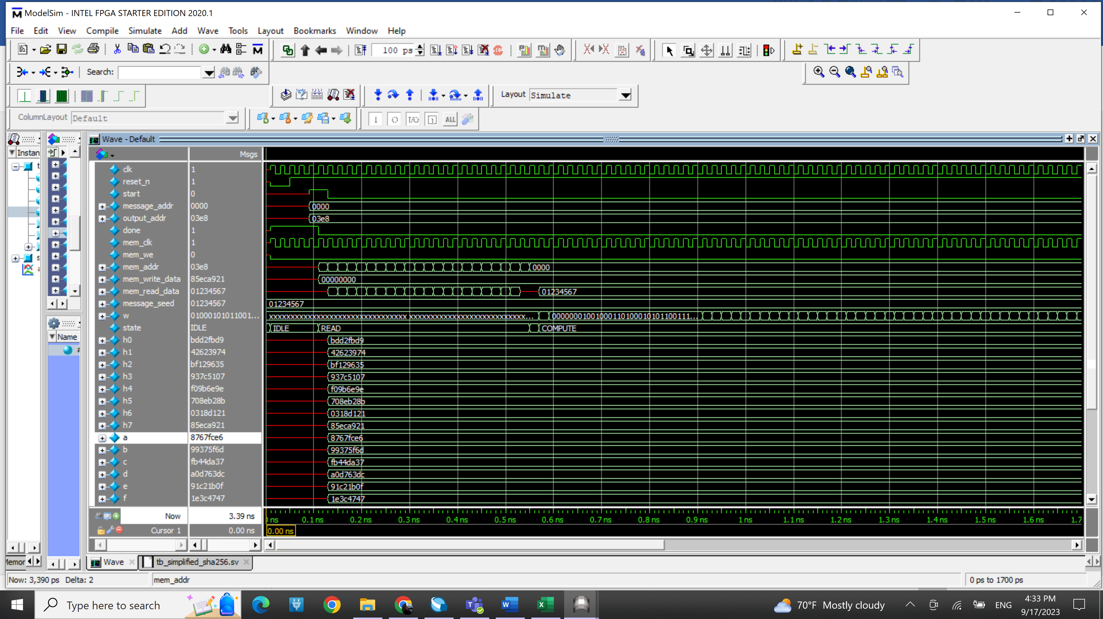

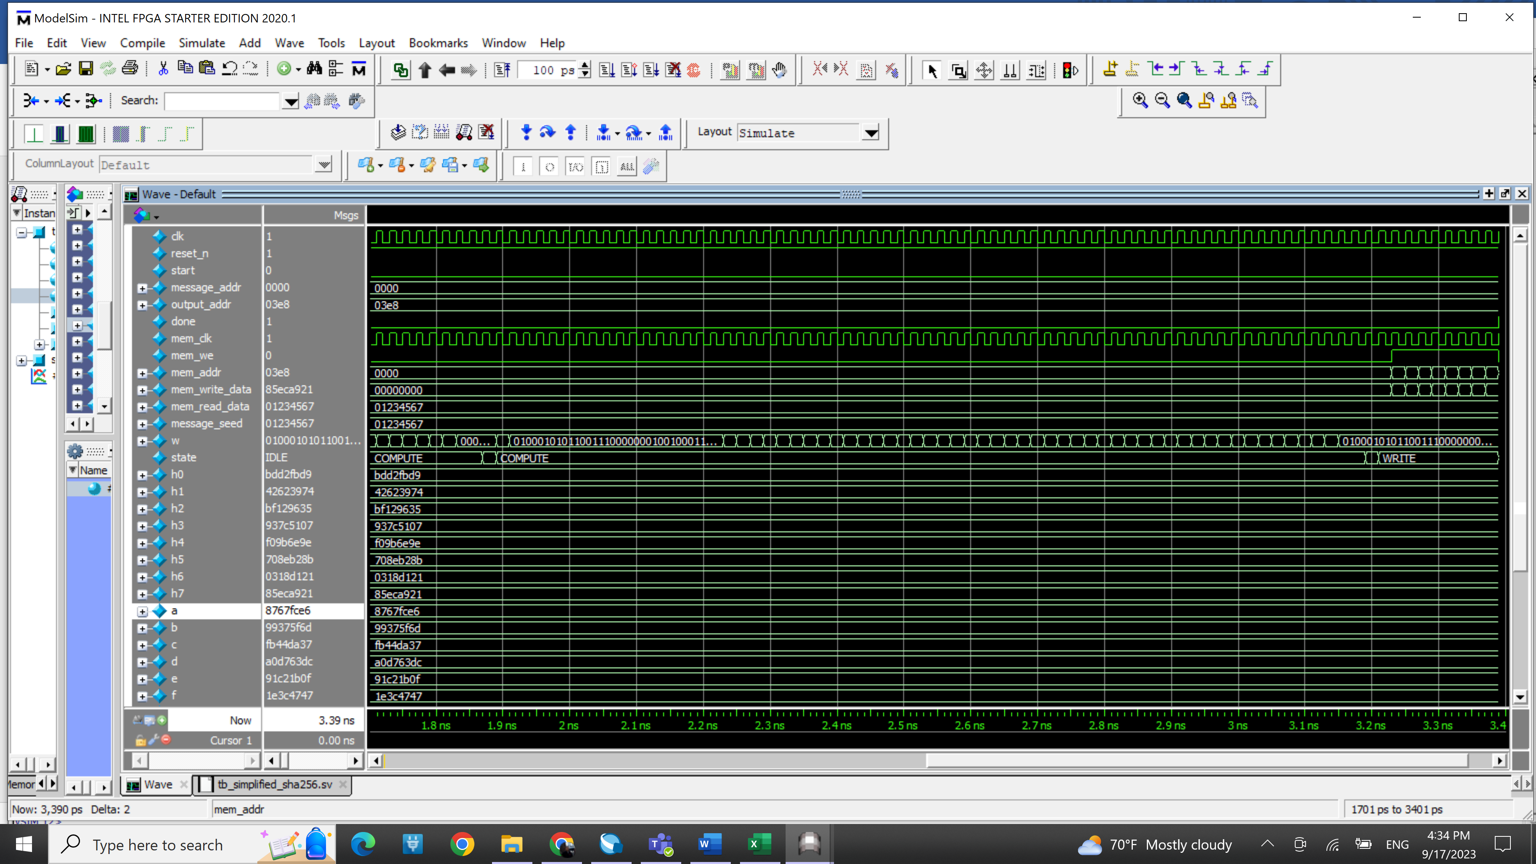

Modelsim transcript

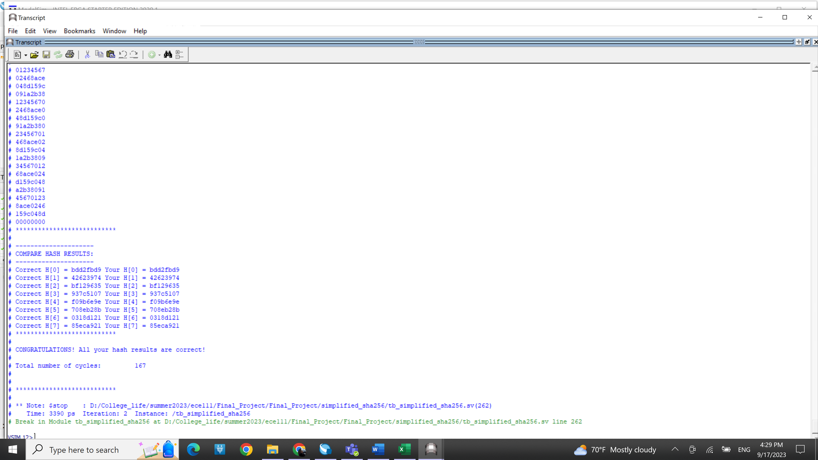

Synthesis resource usage and timing report

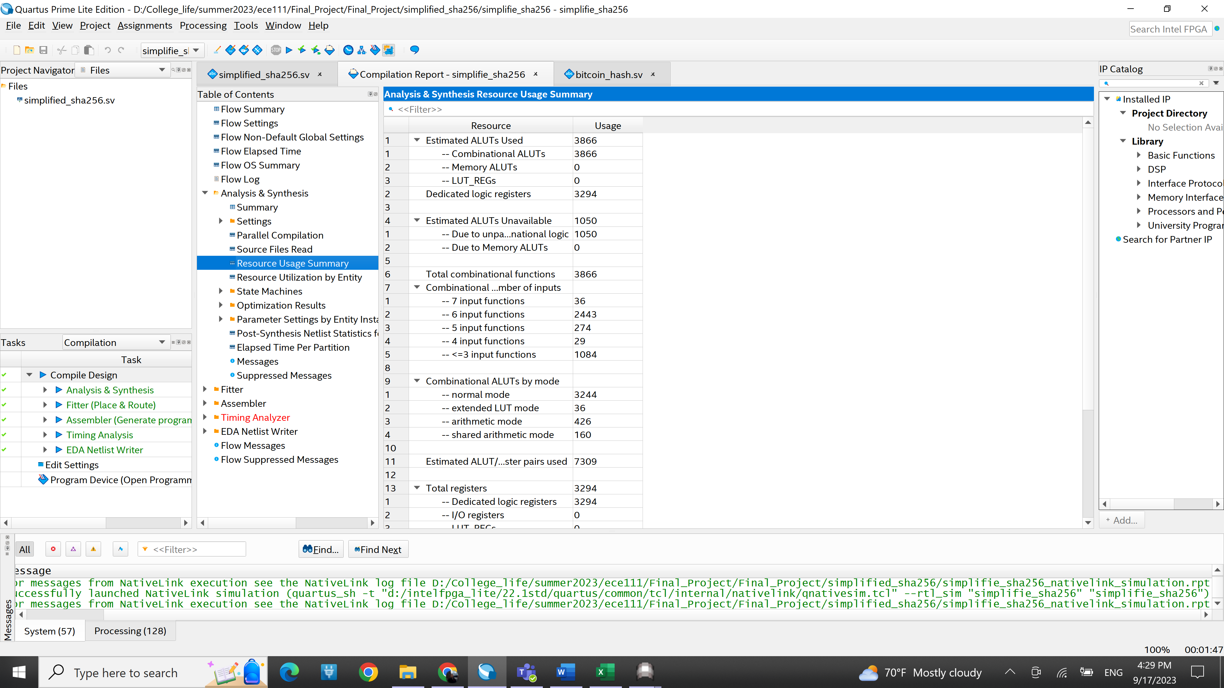

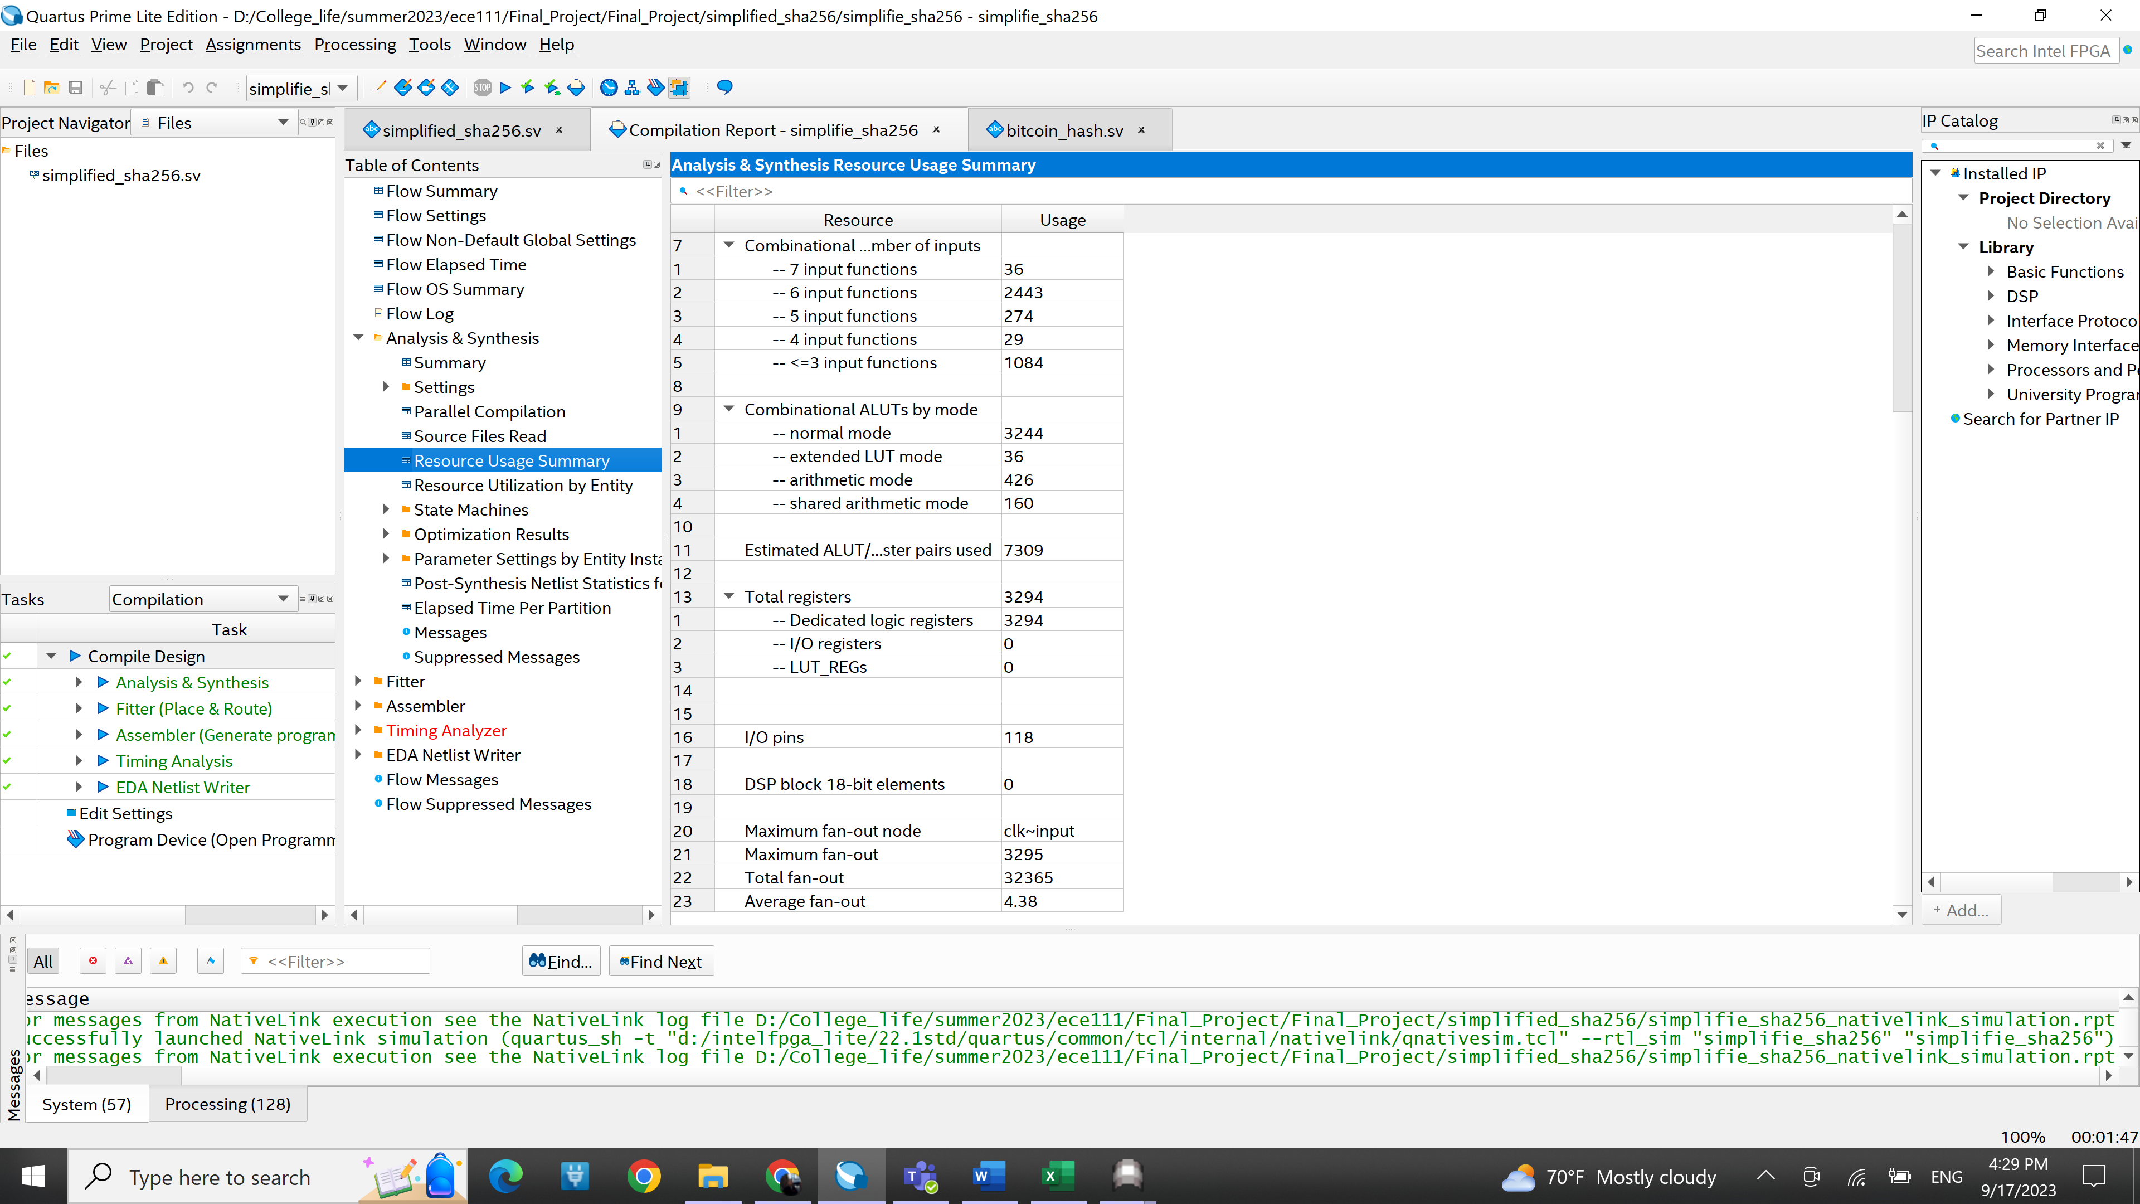

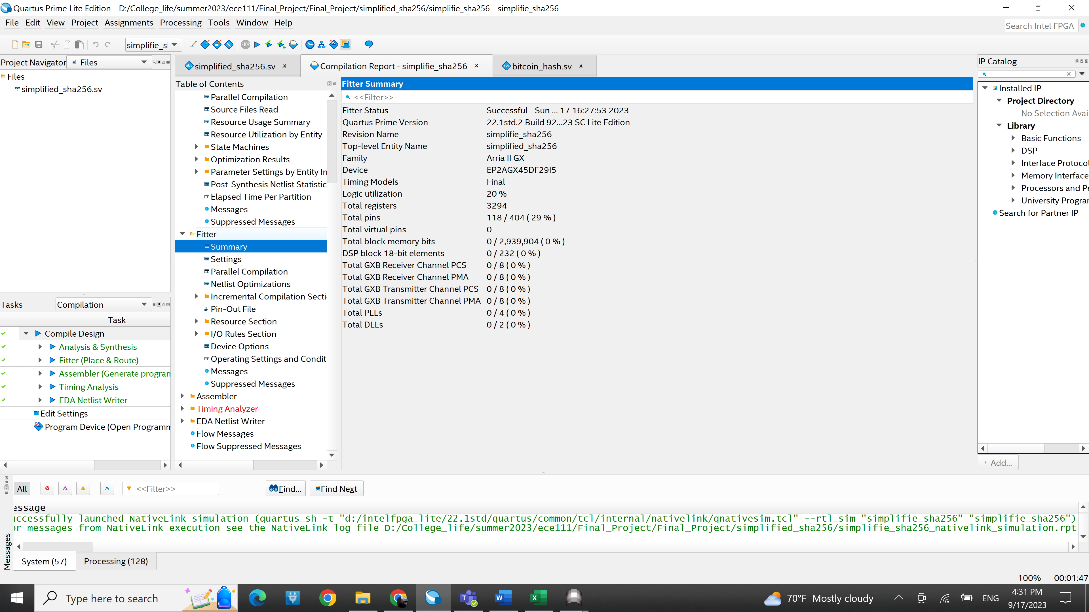

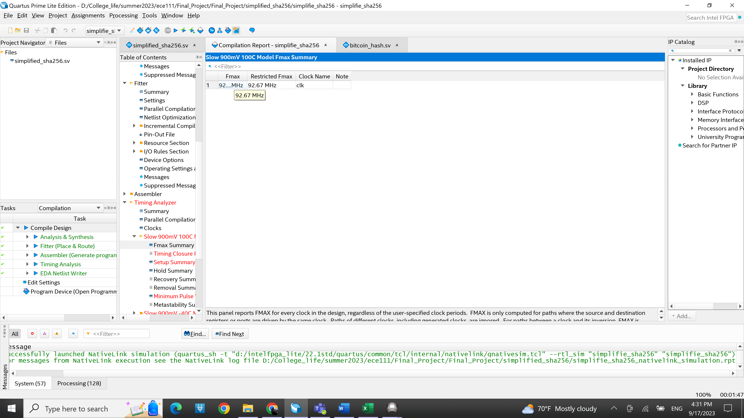

**Bitcoin hashing**

Algorithm

The algorithm here is essentially reuse the SHA256 structure. Since in this project we have to go through 3 SHA256 stages, I have an extra state than SHA256 which is LAST_READ to fulfill the implementation. IDLE state is still for initialization and finalization. And READ is also similar as SHA256 which is reading data from mem_read_data. This time we have 19 32-bit data instead of 20 because the 20th is what we want to figure, namely “nonce”. Still I’m reading data to message, and then goes to BLOCK state. So the first SHA256 phase is pretty much the same as simply using a SHA256. Input is set to the first 512 bit data we just read, so at the end we’ll update the h0 through h7. Now the second phase will take the output from previous phase, which are h0 through h7, and assign them into h0 through h7 and a through h respectively each time it iterates. The reason why it will iterate is that we’re trying to figure which nonce will give us the desired form of output. For simplicity here, we just iterate 16 times(nonce from 0 to 15). And we’re gonna get 16 h0 through h7, which are stored in h0_temp[15:0] through h7_temp[15:0]. (going trhough COMPUTE + BLOCK 16 times) These values will thus be assigned to w[0] through w[7], with [8] through w[15] will be padding of 0 and length. They will then take original given h0 through h7 to go through SHA256. Those assignment are largely done through LAST_READ state, so basically I ‘ll have to go to PRE_READ, then COMPUTE, then BLOCK 16 times, and lastly when all 16 times are done, the resulting values will be stored in h0_f[15:0] through h7_f[15:0] respectively. (if nonce ==0, then stored in h0_f[0] through h7_f[0], etc). Finally, in WRITE state h0_f[15:0] will be written into mem_write_data and set done =1 and go back to IDLE state.

Simulation waveform snapshot

Beginning in time: top

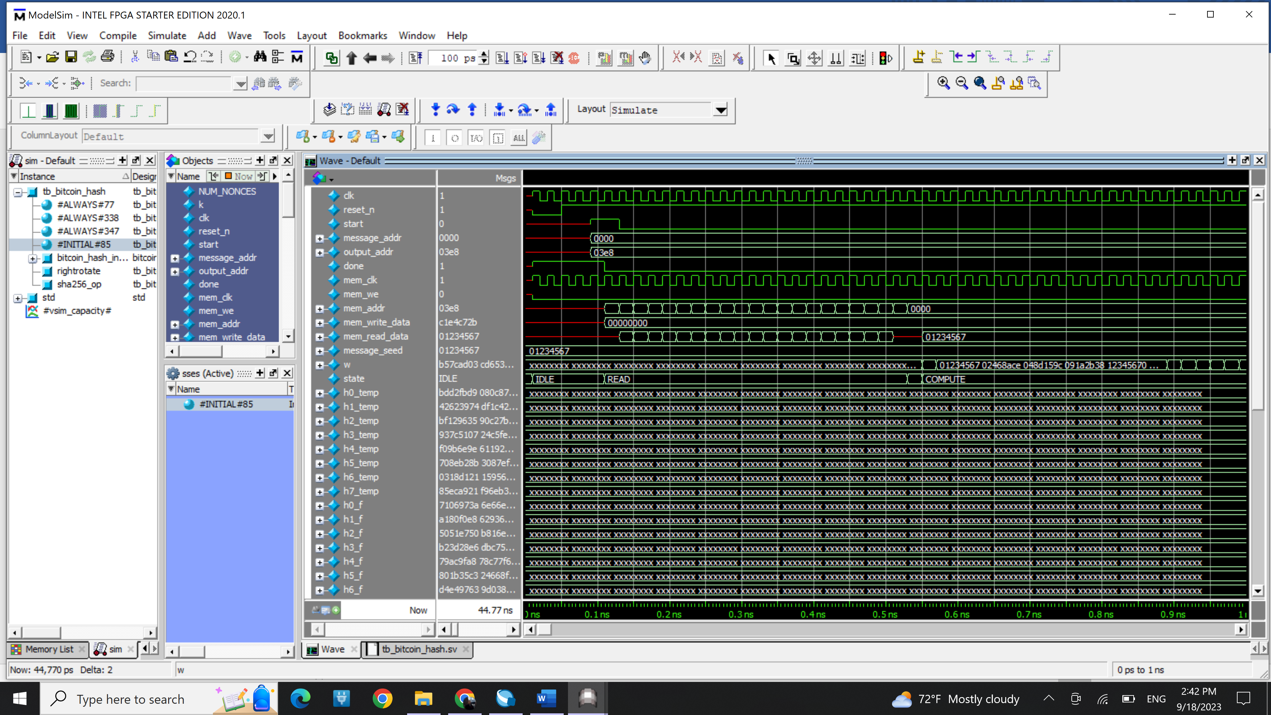

Bottom:

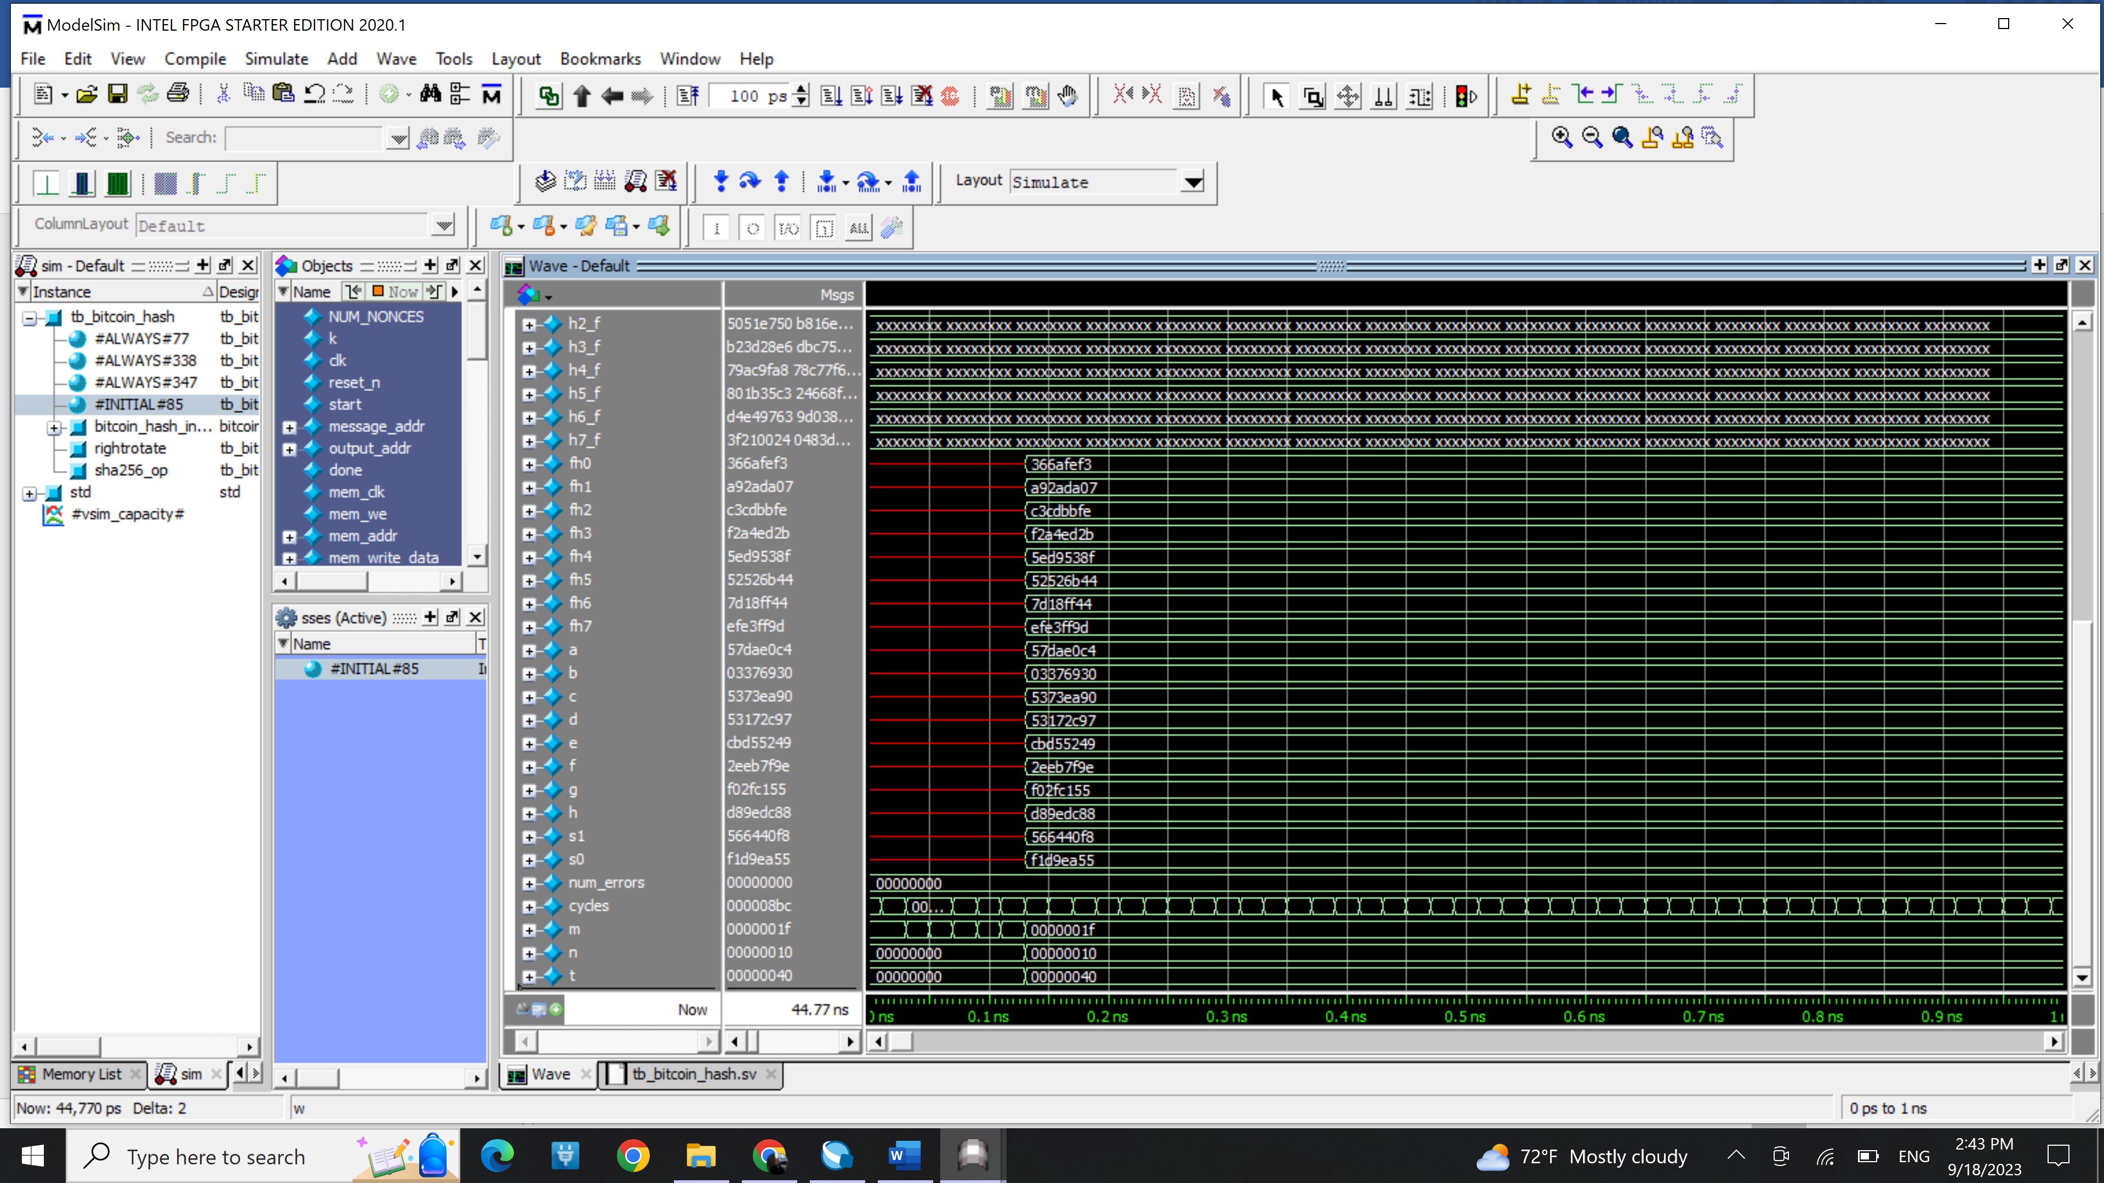

Last part in time: top:

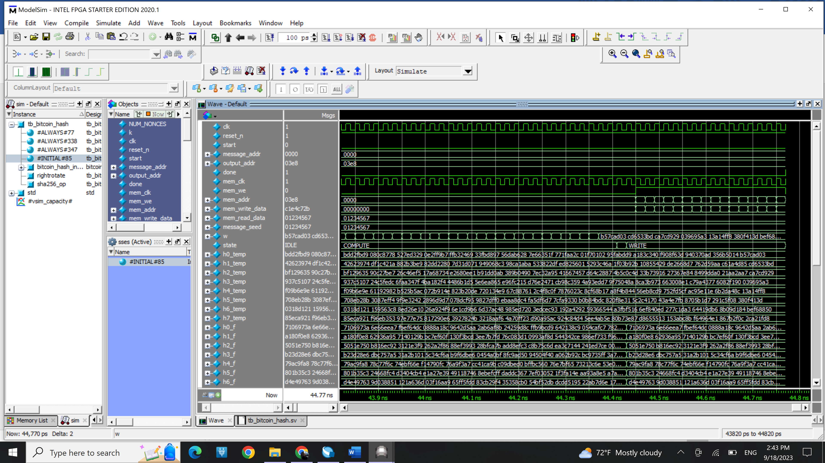

Bottom:

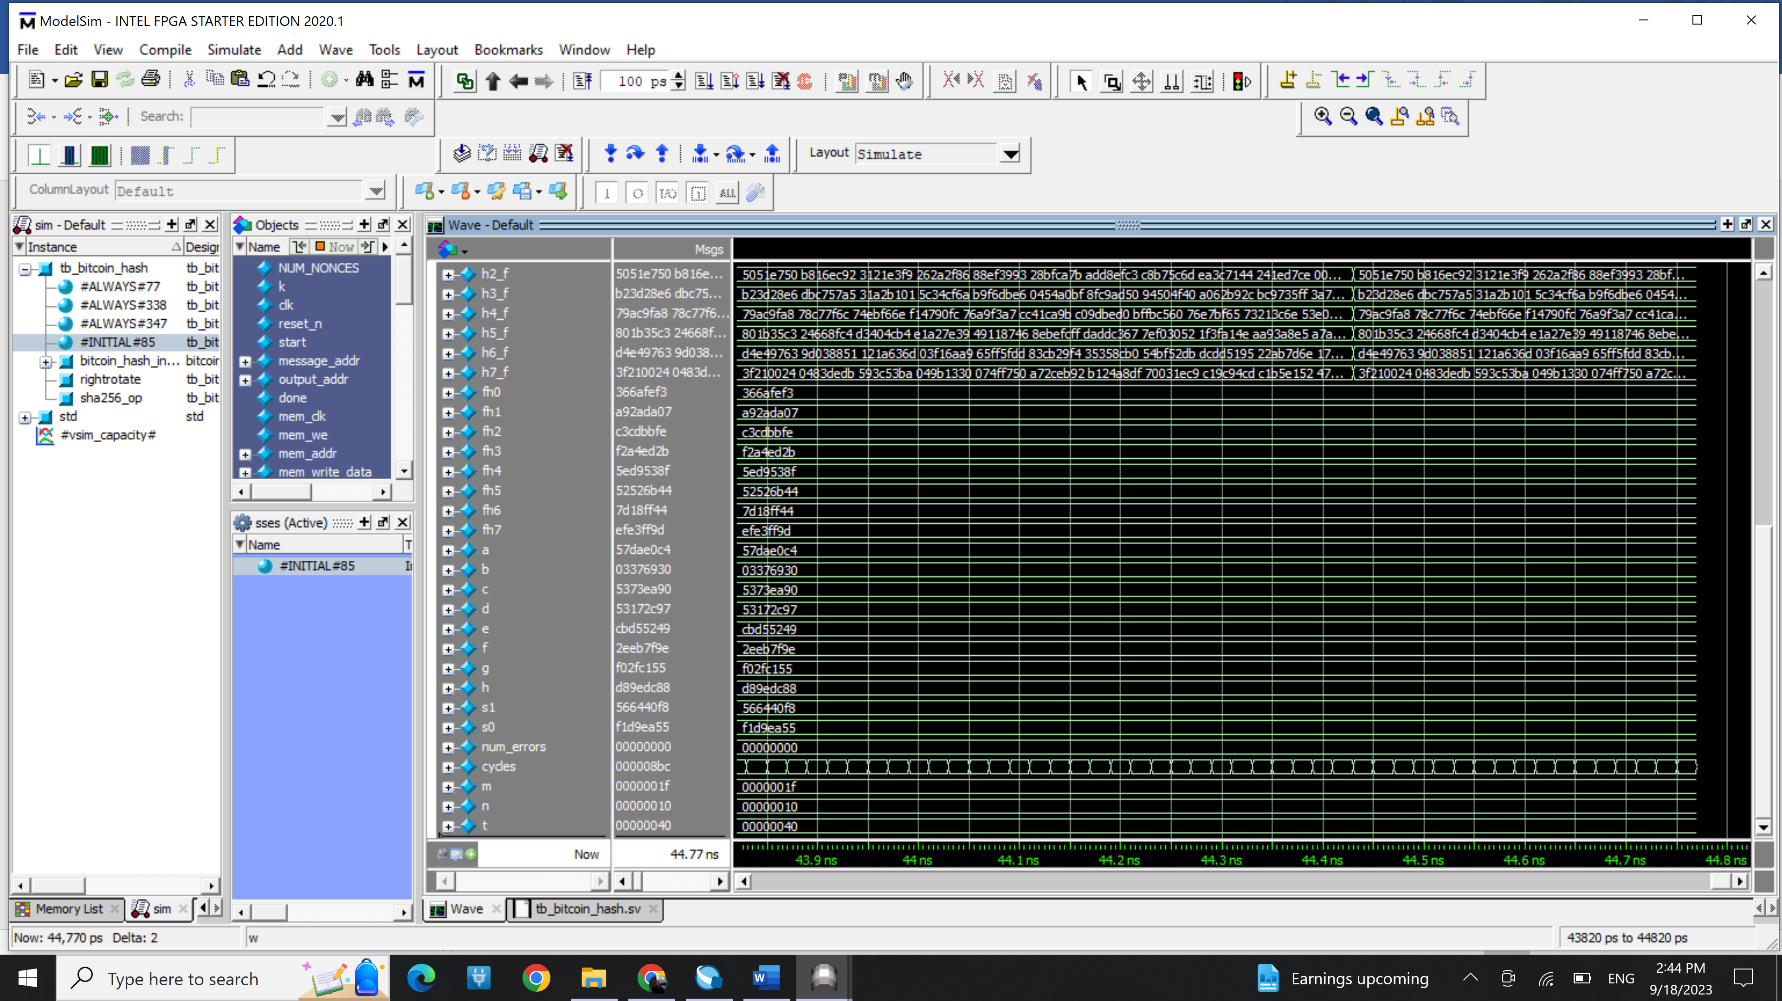

Modelsim transcript

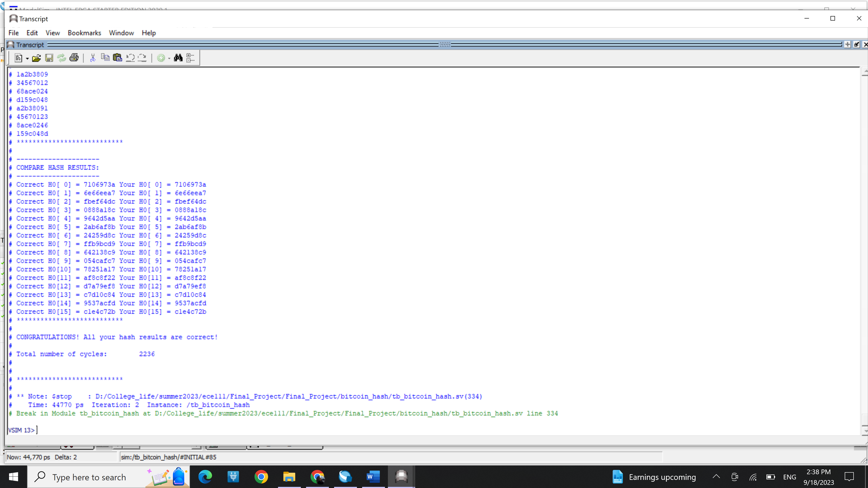

Synthesis resource usage and timing report

